**CS530 Software Engineering Group Project**

**‘User Manual’**

**Dt: 12/12/2016**

Supervisor: Dr.Stan

Team: Scrum Masters

Group Members:

Dhananjay Patankar

Sachin Patel

Liyuan Qin

Pratyusha Surapaneni

**Accessible Link for the application:**

Live Website:

The web application has a live demo at the webpage linked above. Requirements for accessing the application are a modern web browser (Chrome, Firefox, Opera, and newer versions of Internet Explorer) and an internet connection. No installation, sign-up, or log-in required for use of this application. Simply access the website thru your browser. Below is a snapshot of the home screen.

Trip Planner

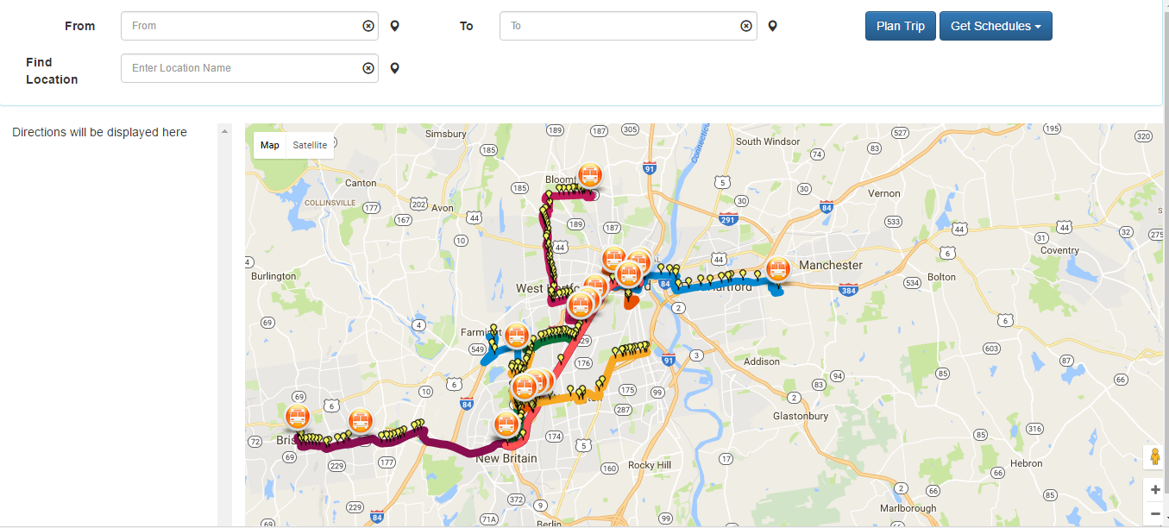

Live Map

Ct-fastrak Routes

Fig: Home Page

Bus Stops

Information sidebar

Bus Current Position

**Main Features:**

**Live Map** - The locations of the CTfastrak buses are dynamically drawn on the map with the bus number and the route name. Every 30 seconds the positions of the buses will automatically update.

**Trip Planner-** The user can find a particular route by entering the source and destination with the application by clicking on the Trip Plan button. The directions will be displayed in the sidebar.

**Find bus stop or location** – The user can search for the particular bus stop or location by entering the station name or location in the find location field.

**View Route Information**- When click on the particular route user can get particular route details with guideway

**View Schedules –**  The user can get the static information of the about the bus timings by selecting the particular route number from the Get Schedule dropdown button or clicking the link provided in the displayed route on the map.

**View Arrival times –** The user may click on one of the bus stops on the CTfastrak line to view the arrival times of buses. This information will display in the side bar.

**Zoom/Pan -** Users can freely pan through the map. Zoom in and out functions are located in the lower right hand corner.

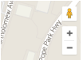

**Fig: Zoom in and out**

**Main Scenario:**

The user can find the route from one location to another location using CTfastrak line.

**Steps:**

1. Enter the starting point in the in the text box “From”. When started entering the location the recommendations will be displayed under the text box. A green circle will be displayed if the location is in range.
2. Enter the destination point in the in the text box “To”. When started entering the location the recommendations will be displayed under the text box. A red circle will be displayed if the location is in range.
3. Click on the “Trip Plan” button to have the route displayed on the map and trip information shown in the sidebar.

Click to find a route

Starting Point

Destination

Source

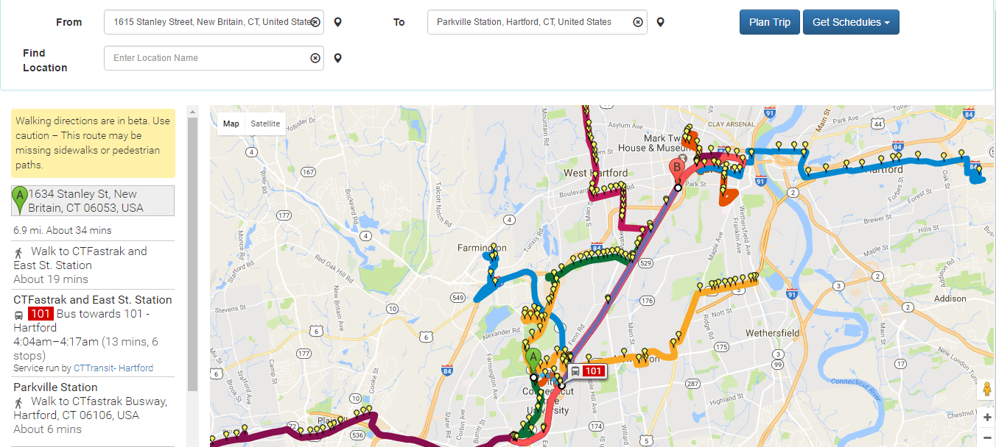

**Fig: Main cenario Outcome**

Trip Information

Recommended Bus

Destination point

**Alternative Scenarios:**

1. **Live Bus Information-** User can get the location of CTfastrak buses.

**Steps:**

* Open up the web application. The live map will automatically display the current bus locations. Buses will automatically update every thirty seconds.
* On the mouse over on any bus, it will display the bus number with route name.

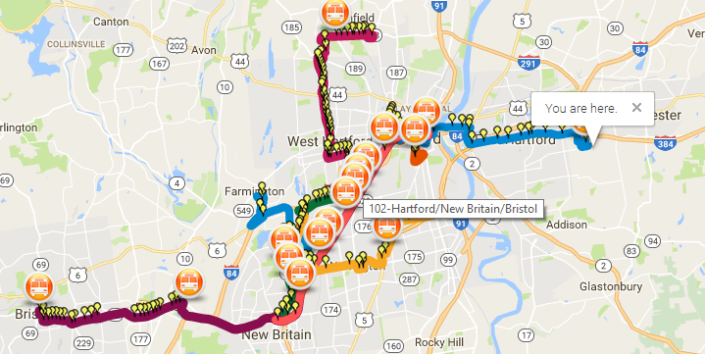

**Fig: Current Buses Location**

1. **Next Arrival buses**- User can view the next few arrival bus timings at any particular bus stop on the CTfastrak line.

Steps:

* Click on one of the bus stops on any route. Then the arrival times will be displayed on the side bar with route-id.

1. **Get Schedules**- Users can get CTfastrak bus schedule

Steps:

* Click on the “Get Schedules” dropdown button on the right corner of the page. Then, it will show the different CTfastrak route numbers. Click on the particular route number and the information will be displayed on the screen.

Get Schedules

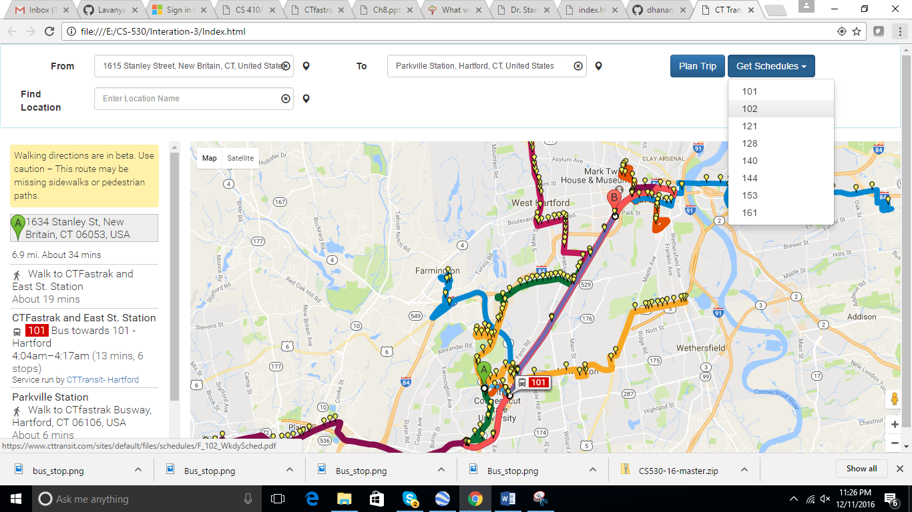

**Fig: Get Schedules**

(or)

* Click on any route on the map then the route information will be displayed with the schedule available link. Click on the provided link and can get the particular schedule as required.

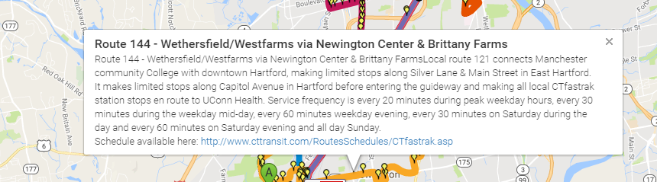

**Fig: Alternative Method for Get Scheduless**

1. **Get Particular Location or Bus Stop by Address:** User can get the particular location or bus stop by entering the location.

**Steps:**

* Enter the required location or bus stop in the textbox “Find Location”. When started entering the location the recommendation will be displayed under the textbox. Then the red icon will be displayed on the location and bus icon will be displayed on the bus stop.

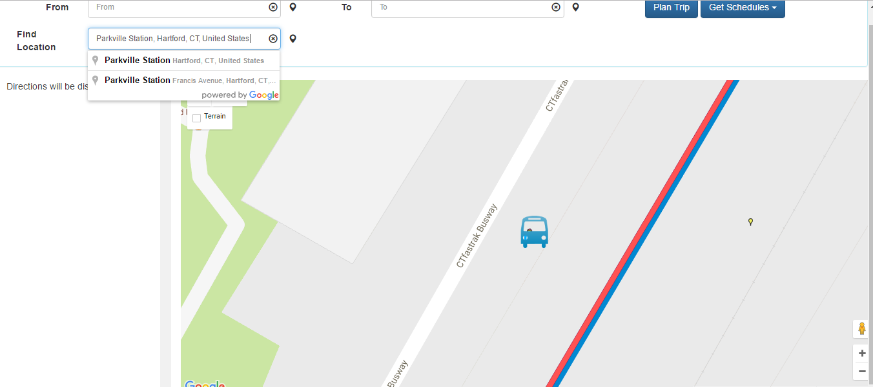

**Fig: Getting Location by address**

Required Location or Bus stop

Bus stop